Module4 lab5

Корначенко Данил

1)
R1

R1#enable
R1#configure terminal
Enter configuration commands, one per line. End with CNTL/Z.
R1(config)#interface f0/0
R1(config-if)#ip address 10.0.0.1 255.255.255.0
R1(config-if)#no shutdown
R1(config-if)#exit
R1(config)#
*Mar 1 00:01:02.943: %LINK-3-UPDOWN: Interface FastEthernet0/0, changed state to up
*Mar 1 00:01:03.943: %LINEPROTO-5-UPDOWN: Line protocol on Interface FastEthernet0/0, changed state to up
R1(config)#interface f1/0
R1(config-if)#ip address 10.0.1.1 255.255.255.252
R1(config-if)#no shutdown
R1(config-if)#exit
R1(config)#e
*Mar 1 00:01:48.451: %LINK-3-UPDOWN: Interface FastEthernet1/0, changed state to up
*Mar 1 00:01:49.451: %LINEPROTO-5-UPDOWN: Line protocol on Interface FastEthernet1/0, changed state to up
R1(config)#end

R2

R2#enable
R2#configure terminal
Enter configuration commands, one per line. End with CNTL/Z.
R2(config)#interface f0/0
R2(config-if)#ip address 10.0.0.2 255.255.255.0
R2(config-if)#no shutdown
R2(config-if)#exit
R2(config)#
*Mar 1 00:01:57.855: %LINK-3-UPDOWN: Interface FastEthernet0/0, changed state to up
*Mar 1 00:01:58.855: %LINEPROTO-5-UPDOWN: Line protocol on Interface FastEthernet0/0, changed state to up
R2(config)#interface f1/0
R2(config-if)#ip address 10.0.2.1 255.255.255.252
R2(config-if)#no shutdown
R2(config-if)#exit
R2(config)#
*Mar 1 00:02:25.279: %LINK-3-UPDOWN: Interface FastEthernet1/0, changed state to up
*Mar 1 00:02:26.279: %LINEPROTO-5-UPDOWN: Line protocol on Interface FastEthernet1/0, changed state to up
R2(config)#end

R3

R3#enable
R3#configure terminal
Enter configuration commands, one per line. End with CNTL/Z.
R3(config)#interface f0/0
R3(config-if)#ip address 10.0.0.3 255.255.255.0
R3(config-if)#no shutdown
R3(config-if)#exit
R3(config)#inte
*Mar 1 00:02:36.619: %LINK-3-UPDOWN: Interface FastEthernet0/0, changed state to up
*Mar 1 00:02:37.619: %LINEPROTO-5-UPDOWN: Line protocol on Interface FastEthernet0/0, changed state to up
R3(config)#interface f1/0
R3(config-if)#ip address 10.0.3.1 255.255.255.252
R3(config-if)#no shutdown
R3(config-if)#exit
R3(config)#
*Mar 1 00:03:04.943: %LINK-3-UPDOWN: Interface FastEthernet1/0, changed state to up
*Mar 1 00:03:05.943: %LINEPROTO-5-UPDOWN: Line protocol on Interface FastEthernet1/0, changed state to up
R3(config)#interface e2/0
R3(config-if)#ip address 10.0.4.1 255.255.255.252
R3(config-if)#no shutdown
R3(config-if)#exit
R3(config)#end

R4

R4#enable
R4#configure terminal
Enter configuration commands, one per line. End with CNTL/Z.
R4(config)#interface f0/0
R4(config-if)#ip address 10.0.1.2 255.255.255.252
R4(config-if)#no shutdown
R4(config-if)#exit
R4(config)#int
*Mar 1 00:03:34.659: %LINK-3-UPDOWN: Interface FastEthernet0/0, changed state to up
*Mar 1 00:03:35.659: %LINEPROTO-5-UPDOWN: Line protocol on Interface FastEthernet0/0, changed state to up
R4(config)#interface f1/0
R4(config-if)#ip address 192.168.1.1 255.255.255.0
R4(config-if)#no shutdown
R4(config-if)#exit
R4(config)#end

R5

R5#enable
R5#configure terminal
Enter configuration commands, one per line. End with CNTL/Z.
R5(config)#interface e2/0
R5(config-if)#ip address 192.168.2.1 255.255.255.0
R5(config-if)#no shutdown
R5(config-if)#exit
R5(config)#inter
*Mar 1 00:04:22.915: %LINK-3-UPDOWN: Interface Ethernet2/0, changed state to up
*Mar 1 00:04:23.915: %LINEPROTO-5-UPDOWN: Line protocol on Interface Ethernet2/0, changed state to up
R5(config)#interface f0/0
R5(config-if)#ip address 10.0.2.2 255.255.255.252
R5(config-if)#no shutdown
R5(config-if)#exit
R5(config)#inter
*Mar 1 00:04:45.899: %LINK-3-UPDOWN: Interface FastEthernet0/0, changed state to up
*Mar 1 00:04:46.899: %LINEPROTO-5-UPDOWN: Line protocol on Interface FastEthernet0/0, changed state to up
R5(config)#interface f1/0
R5(config-if)#ip address 10.0.3.2 255.255.255.252
R5(config-if)#no shutdown
R5(config-if)#exit
R5(config)#end

R6

R6#enable
R6#configure terminal
Enter configuration commands, one per line. End with CNTL/Z.
R6(config)#interface f0/0
R6(config-if)#ip address 10.0.4.2 255.255.255.252
R6(config-if)#no shutdown
R6(config-if)#exit
R6(config)#
*Mar 1 00:05:11.219: %LINK-3-UPDOWN: Interface FastEthernet0/0, changed state to up
*Mar 1 00:05:12.223: %LINEPROTO-5-UPDOWN: Line protocol on Interface FastEthernet0/0, changed state to up
R6(config)#interface e2/0
R6(config-if)#ip address 10.0.5.1 255.255.255.252
R6(config-if)#no shutdown
R6(config-if)#exit
R6(config)#
*Mar 1 00:05:43.411: %LINK-3-UPDOWN: Interface Ethernet2/0, changed state to up
*Mar 1 00:05:44.411: %LINEPROTO-5-UPDOWN: Line protocol on Interface Ethernet2/0, changed state to up
R6(config)#interface f1/0
R6(config-if)#ip address 192.168.3.1 255.255.255.0
R6(config-if)#no shutdown
R6(config-if)#exit
R6(config)#
*Mar 1 00:06:11.539: %LINK-3-UPDOWN: Interface FastEthernet1/0, changed state to up
*Mar 1 00:06:12.539: %LINEPROTO-5-UPDOWN: Line protocol on Interface FastEthernet1/0, changed state to up
R6(config)#end

R7

R7#enable
R7#configure terminal
Enter configuration commands, one per line. End with CNTL/Z.
R7(config)#interface e2/0
R7(config-if)#ip address 10.0.5.2 255.255.255.252
R7(config-if)#no shutdown
R7(config-if)#exit
R7(config)#
*Mar 1 00:06:07.343: %LINK-3-UPDOWN: Interface Ethernet2/0, changed state to up
*Mar 1 00:06:08.343: %LINEPROTO-5-UPDOWN: Line protocol on Interface Ethernet2/0, changed state to up
R7(config)#interface f0/0
R7(config-if)#ip address 10.0.6.1 255.255.255.252
R7(config-if)#no shutdown
R7(config-if)#exit
R7(config)#
*Mar 1 00:06:39.347: %LINK-3-UPDOWN: Interface FastEthernet0/0, changed state to up
*Mar 1 00:06:40.347: %LINEPROTO-5-UPDOWN: Line protocol on Interface FastEthernet0/0, changed state to up
R7(config)#interface f1/0
R7(config-if)#ip address 192.168.4.1 255.255.255.0
R7(config-if)#no shutdown
R7(config-if)#exit
R7(config)#
*Mar 1 00:07:09.447: %LINK-3-UPDOWN: Interface FastEthernet1/0, changed state to up
*Mar 1 00:07:10.447: %LINEPROTO-5-UPDOWN: Line protocol on Interface FastEthernet1/0, changed state to up
R7(config)#end

R8

R8#enable
R8#configure terminal
Enter configuration commands, one per line. End with CNTL/Z.
R8(config)#interface f0/0
R8(config-if)#ip address 10.0.6.2 255.255.255.252
R8(config-if)#no shutdown
R8(config-if)#exit
R8(config)#
*Mar 1 00:07:01.591: %LINK-3-UPDOWN: Interface FastEthernet0/0, changed state to up
*Mar 1 00:07:02.591: %LINEPROTO-5-UPDOWN: Line protocol on Interface FastEthernet0/0, changed state to up
R8(config)#interface f1/0
R8(config-if)#ip address 192.168.5.1 255.255.255.0
R8(config-if)#no shutdown
R8(config-if)#exit
R8(config)#
*Mar 1 00:07:29.955: %LINK-3-UPDOWN: Interface FastEthernet1/0, changed state to up
*Mar 1 00:07:30.955: %LINEPROTO-5-UPDOWN: Line protocol on Interface FastEthernet1/0, changed state to up
R8(config)#end

Layer2Switch-1

vIOS-L2-01>enable
vIOS-L2-01#configure terminal
Enter configuration commands, one per line. End with CNTL/Z.
vIOS-L2-01(config)#interface vlan 1
vIOS-L2-01(config-if)#ip address 10.0.0.10 255.255.255.0
vIOS-L2-01(config-if)#no shutdown
vIOS-L2-01(config-if)#exit
vIOS-L2-01(config)#ip default-gateway 10.0.0.1
vIOS-L2-01(config)#end

PC1

PC1> ip 192.168.1.2 255.255.255.0 192.168.1.1
Checking for duplicate address...
PC1 : 192.168.1.2 255.255.255.0 gateway 192.168.1.1

PC2

PC2> ip 192.168.2.2 255.255.255.0 192.168.2.1
Checking for duplicate address...
PC2 : 192.168.2.2 255.255.255.0 gateway 192.168.2.1

PC3

PC3> ip 192.168.3.2 255.255.255.0 192.168.3.1
Checking for duplicate address...
PC3 : 192.168.3.2 255.255.255.0 gateway 192.168.3.1
PC4

PC4> ip 192.168.4.2 255.255.255.0 192.168.4.1
Checking for duplicate address...
PC4 : 192.168.4.2 255.255.255.0 gateway 192.168.4.1

PC5

PC5> ip 192.168.5.2 255.255.255.0 192.168.5.1
Checking for duplicate address...
PC5 : 192.168.5.2 255.255.255.0 gateway 192.168.5.1

2) Настройка RIP v2 — no auto-summary отключает автоматическое суммирование на границах классов, без этого бы получилась каша — 192.168.1.0 была бы объявлена как класс В

R1

R1#enable
R1#configure terminal
Enter configuration commands, one per line. End with CNTL/Z.
R1(config)#router rip
R1(config-router)#version 2
R1(config-router)#no auto-summary
R1(config-router)#network 10.0.1.0
R1(config-router)#exit
R1(config)#end

R4

R4#enable
R4#configure terminal
Enter configuration commands, one per line. End with CNTL/Z.
R4(config)#router rip
R4(config-router)#version 2
R4(config-router)#no auto-summary
R4(config-router)#network 10.0.1.0
R4(config-router)#network 192.168.1.0
R4(config-router)#exit
R4(config)#end

R2

R2#enable
R2#configure terminal
Enter configuration commands, one per line. End with CNTL/Z.
R2(config)#router rip
R2(config-router)#version 2
R2(config-router)#no auto-summary
R2(config-router)#network 10.0.2.0
R2(config-router)#exit
R2(config)#end

R3

R3#enable
R3#configure terminal
Enter configuration commands, one per line. End with CNTL/Z.
R3(config)#router rip
R3(config-router)#version 2
R3(config-router)#no auto-summary
R3(config-router)#network 10.0.3.0
R3(config-router)#exit
R3(config)#end

R5

R5#enable
R5#configure terminal
Enter configuration commands, one per line. End with CNTL/Z.
R5(config)#router rip
R5(config-router)#version 2
R5(config-router)#no auto-summary
R5(config-router)#network 10.0.2.0
R5(config-router)#network 10.0.3.0
R5(config-router)#network 192.168.2.0
R5(config-router)#exit

3) Настройка OSPF

R1

R1#configure terminal
Enter configuration commands, one per line. End with CNTL/Z.
R1(config)#router ospf 1
R1(config-router)#network 10.0.0.0 0.0.0.255 area 0
R1(config-router)#exit
R1(config)#end

R2

R2#configure terminal
Enter configuration commands, one per line. End with CNTL/Z.
R2(config)#router ospf 1
R2(config-router)#network 10.0.0.0 0.0.0.255 area 0
R2(config-router)#ne
*Mar 1 01:16:40.139: %OSPF-5-ADJCHG: Process 1, Nbr 10.0.1.1 on FastEthernet0/0 from LOADING to FULL, Loading Done
R2(config-router)#network 10.0.2.0 0.0.0.3 area 2
R2(config-router)#exit
R2(config)#end

R3

R3#configure terminal
Enter configuration commands, one per line. End with CNTL/Z.
R3(config)#router ospf 1
R3(config-router)#network 10.0.0.0 0.0.0.255 area 0
R3(config-router)#
*Mar 1 01:17:51.731: %OSPF-5-ADJCHG: Process 1, Nbr 10.0.1.1 on FastEthernet0/0 from LOADING to FULL, Loading Done
*Mar 1 01:17:51.735: %OSPF-5-ADJCHG: Process 1, Nbr 10.0.2.1 on FastEthernet0/0 from LOADING to FULL, Loading Done
R3(config-router)#network 10.0.3.0 0.0.0.3 area 2
R3(config-router)#network 10.0.4.0 0.0.0.3 area 1
R3(config-router)#area 1 stub no-summary
R3(config-router)#exit
R3(config)#end

R5

R5#configure terminal
Enter configuration commands, one per line. End with CNTL/Z.
R5(config)#router ospf 1
R5(config-router)#network 10.0.2.0 0.0.0.3 area 2
R5(config-router)#network 10.0.3.0 0.0.0.3 area 2
R5(config-router)#network 192.168.2.0 0.0.0.255 area 2
R5(config-router)#exit
R5(config)#end

R6

R6#configure terminal
Enter configuration commands, one per line. End with CNTL/Z.
R6(config)#router ospf 1
R6(config-router)#network 10.0.4.0 0.0.0.3 area 1
R6(config-router)#network 10.0.5.0 0.0.0.3 area 1
R6(config-router)#network 192.168.3.0 0.0.0.255 area 1
R6(config-router)#area 1 stub
R6(config-router)#exit
R6(config)#end

R7

R7#configure terminal
Enter configuration commands, one per line. End with CNTL/Z.
R7(config)#router ospf 1
R7(config-router)#network 10.0.5.0 0.0.0.3 area 1
R7(config-router)#network 10.0.6.0 0.0.0.3 area 1
R7(config-router)#network 192.168.4.0 0.0.0.255 area 1
R7(config-router)#area 1 stub
R7(config-router)#exit
R7(config)#end

R8

R8#configure terminal
Enter configuration commands, one per line. End with CNTL/Z.
R8(config)#router ospf 1
R8(config-router)#network 10.0.6.0 0.0.0.3 area 1
R8(config-router)#network 192.168.5.0 0.0.0.255 area 1
R8(config-router)#area 1 stub
R8(config-router)#exit
R8(config)#end

4)

R1

R1#configure terminal
Enter configuration commands, one per line. End with CNTL/Z.
R1(config)#router rip
R1(config-router)#redistribute ospf 1 metric 3
R1(config-router)#exit
R1(config)#router ospf 1
R1(config-router)#redistribute rip subnets
R1(config-router)#exit
R1(config)#end

R2

R2#configure terminal
Enter configuration commands, one per line. End with CNTL/Z.
R2(config)#router rip
R2(config-router)#redistribute ospf 1 metric 3
R2(config-router)#exit
R2(config)#router ospf 1
R2(config-router)#redistribute rip subnets
R2(config-router)#exit

R3

R3#configure terminal
Enter configuration commands, one per line. End with CNTL/Z.
R3(config)#router rip
R3(config-router)#redistribute ospf 1 metric 3
R3(config-router)#exit
R3(config)#router ospf 1
R3(config-router)#redistribute rip subnets
R3(config-router)#exit
R3(config)#end

5)

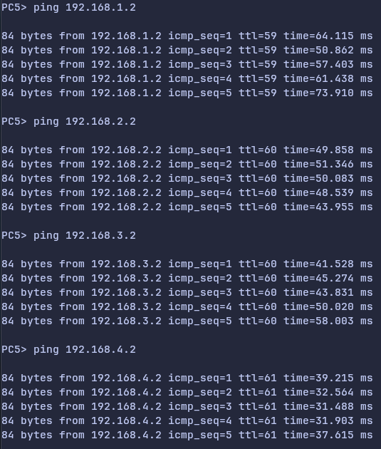

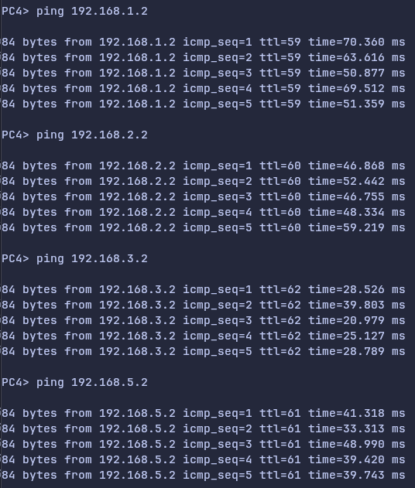

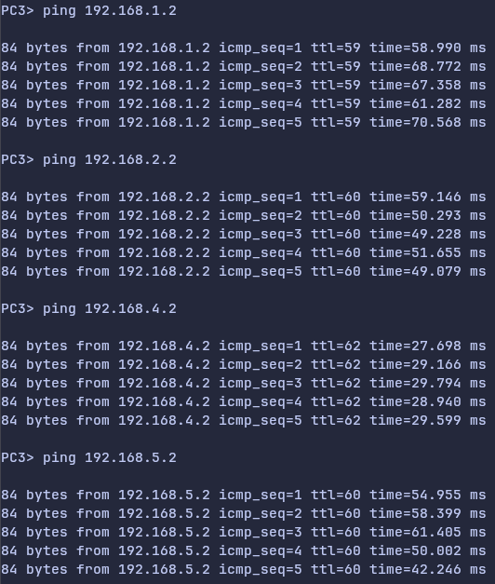

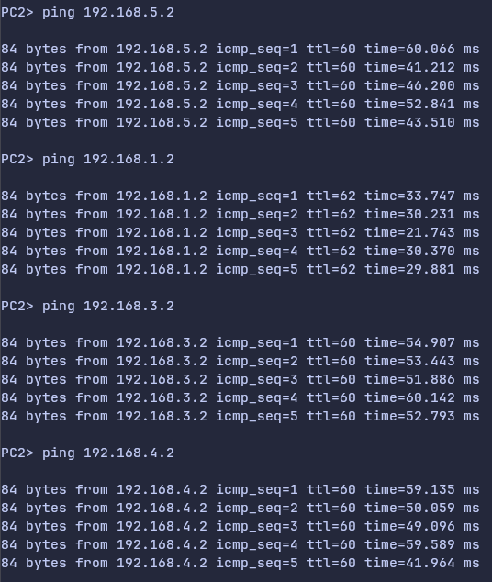

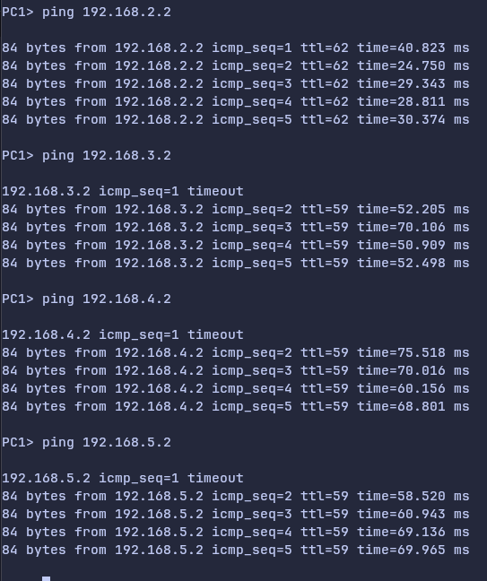

6)

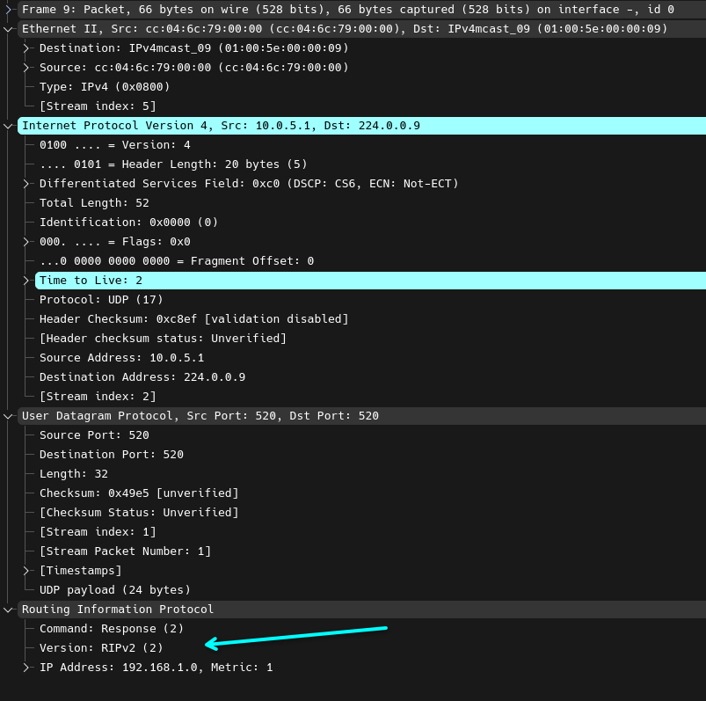

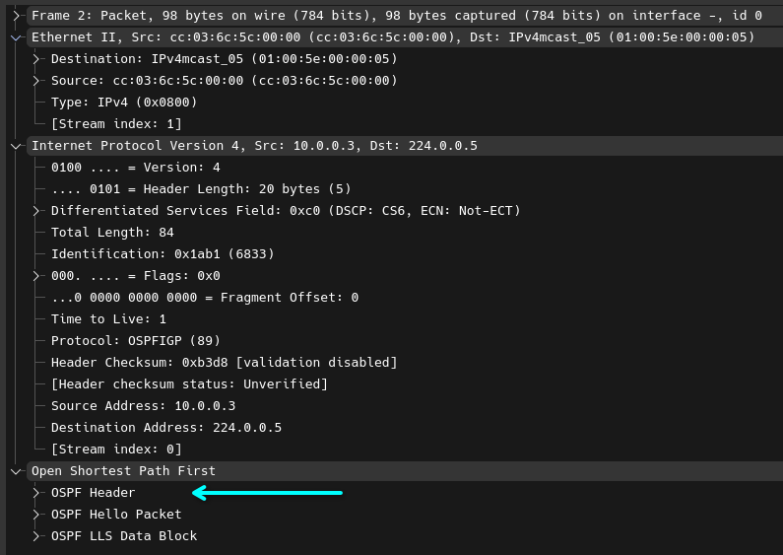

7)

8)

